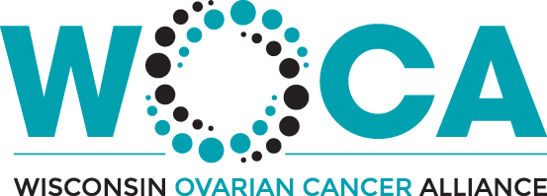

2023 Event Sponsorship Package

Contact: Ashley Schneider, Executive Director; ashley@wisconsinovariancancer.org; 262-797-7804

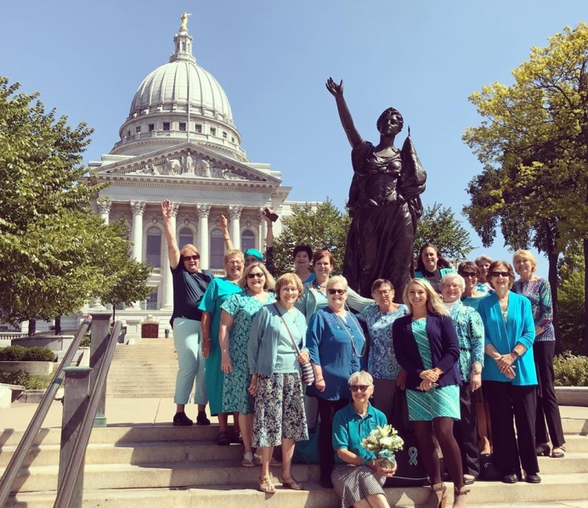

About WOCA and Ovarian Cancer

Our Mission
The Wisconsin Ovarian Cancer Alliance is committed to providing support, education, and Funding of Research for Ovarian Cancer throughout Wisconsin.

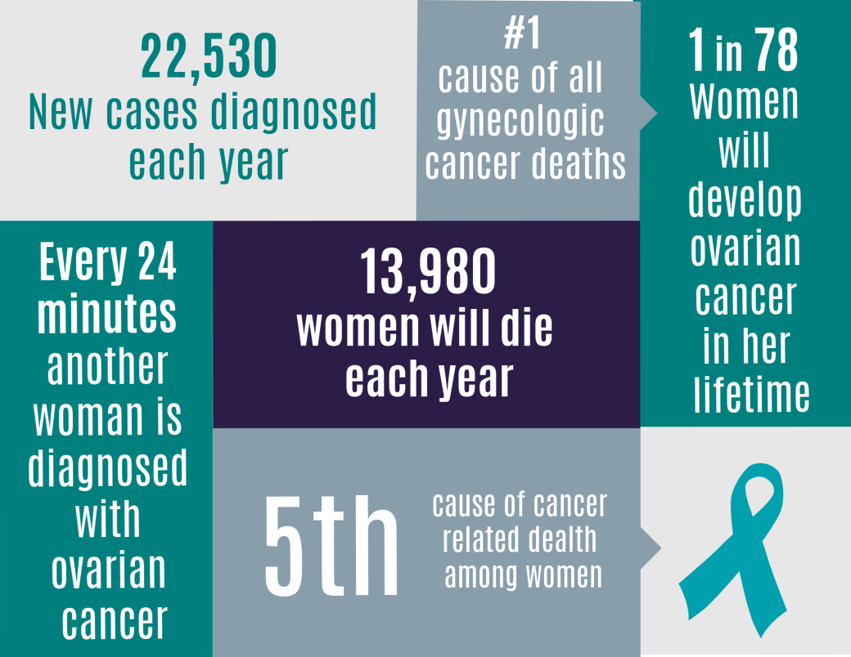

About Ovarian Cancer
Historically ovarian cancer was called the “silent killer” because symptoms were not thought to develop until the chance of cure was poor. However, recent studies have shown this term is untrue and the following symptoms are much more likely to occur in women with ovarian cancer than women in the general population.

These symptoms include: Bloating, Eating Difficulty or feeling full quickly, Abdominal or pelvic pain, and Troubles with your bladder (urgency or frequency). This is commonly referred to as the B.E.A.T.

Risk Factors of Ovarian Cancer include: Increasing Age, Reproductive History and Infertility, Obesity, and Genetic Mutations like BRCA1 or BRCA2.

WOCA offers several support services to the Ovarian Cancer community that can assist survivors through the emotional aspects of a diagnosis. Such of these services include:

Research Funding
WOCA provides funding to Ovarian Cancer researchers located at facilities throughout Wisconsin.

Financial Assistance – “Teal in Need” and “Connie Rutledge Legacy Fund”
These programs provide financial assistance to women undergoing treatment for Gynecologic Cancer.

Woman to Woman Mentorship Program
Through this program, we pair women who are newly diagnosed with women who are farther along in their journey.

Comfort Totes / Cups of Comfort
WOCA distributes “Comfort Totes” to number of facilities for women to be given upon an ovarian cancer diagnosis.

Meet WOCA
Meet WOCA is a traveling support group held in different cities throughout Wisconsin. Meet WOCA is open to anyone wanting to learn more about the organization.

Support Groups
WOCA holds support groups for Ovarian Cancer Survivors and their caregivers.

Scholarships
Annually, WOCA provides scholarship to survivors to attend Camp Mak-A-Dream or OCRFA's Annual Conference.

Our events for the 2023 Fiscal Year

Event: Ovarian Cancer Survivor’s Brunch
Date: April 23rd, 2023 – In person Event , April 25th – 27th, 2023 - Virtual Events
Time: 9:00am - 2:00pm
Location: The Wisconsin Club (900 W. Wisconsin Ave., Milwaukee WI 53233)

Event: Power Up For Purple
Date: August 20th, 2023
Time: 8:00am - 11:30am
Location: Green Bay Botanical Gardens (2600 Larsen Rd. Green Bay, WI 54303)

Event: WOCA’s Nancy’s Run, Rock & Stroll
Date: September 16th, 2023
Time: 8:00am-11:30am
Location: Greenfield Park - Cool Waters (2028 S. 124th St., West Allis, WI 53227)

Event: WOCA’s Whisper Walk
Date: September 24th, 2023
Time: 8:00am-11:30am
Location: McKee Farms Park (2930 Chapel Valley Rd., Fitchburg, WI 53711)

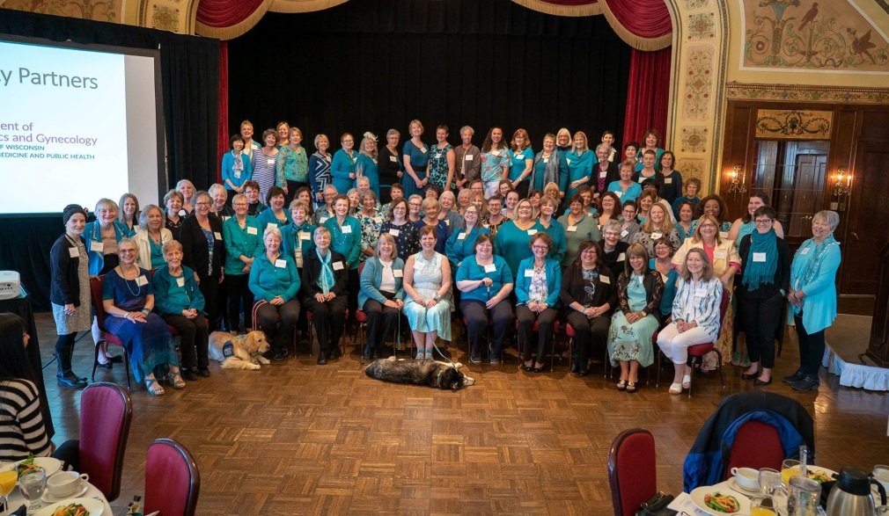

There are so many ways to get involved!!!

- Sponsor: Please refer to the enclosed sponsorship opportunities for details. When you sponsor one of our events, you are directly supporting our mission, and helping those diagnosed with ovarian cancer in Wisconsin.

- Donate Goods or Services: Consider making an in-kind donation of good or services to the event of your choosing.

- Volunteer at one of our events

- Attend an event

- Donate towards the cause

Sponsor WOCA’s Annual:
“Ovarian Cancer Survivor’s Brunch”
This year brunch will be a hybrid event of our in person brunch on April 23rd, 2023, followed by virtual webinars April 25th – April 27th , 2023.

Teal Level ($5,000)
- All Items In Table Sponsorship Plus:
  - Company Logo PROMINENTLY displayed on sponsorship board
  - 10 seats provided at the event
  - One Page of Advertising Space in Event Program*
  - Table Tent on your table with company / logo listed
  - Company / Family Name represented in our PowerPoint Presentation. Slide will run for 60 seconds
  - Promotional Table Space available in the “Expert Expo”. Staffed by one of your medical professionals
  - Opportunity to host a one hour webinar at our virtual brunch April 25-27th, 2023

Platinum Level ($2,500)
- All Items In Table Sponsorship Plus:
  - 6 seats provided at the event
  - Half Page of Advertising Space in Event Program*
  - Table Tent on your table with company / logo listed
  - Company / Family Name represented in our PowerPoint Presentation. Slide will run for 30 seconds
  - Promotional Table Space available in the “Expert Expo”. Staffed by one of your medical professionals.
  - Opportunity to host a one hour webinar at our virtual brunch April 25-27th, 2023

Table Sponsor ($1,000)
- Company Name and Logo listed on all WOCA social media sites
- Company Logo listed on event program
- Company Logo PROMINENTLY displayed on sponsorship board
- 4 seats provided at the event
- Quarter Page of Advertising Space in Event Program*
- Table Tent on your table with company / logo listed
- Company / Family Name represented in our PowerPoint Presentation. Slide will run for 15 seconds

We are able to customize and create any packages you see fit. Please contact ashley@wisconsinovariancancer.org to discuss for your budget and needs.

*Sponsor must provide event program advertising layout to WOCA by April 1st, 2022.
All event programs are 8 _{1/2} by 5 _{1/2. .}Please provide appropriate sizing according to your sponsorship level.
Please email all logos to ashley@wisconsniovariancancer.org
Sponsor WOCA’s Annual Run/Walks:
“Power Up For Purple” – August 20th, 2023
“Nancy’s Run, Rock, and Stroll” – September 16th, 2023
“Whisper Walk” – September 24th, 2023

Event Sponsorships:

Presenting Sponsor ($10,000)
- All Items in Diamond Level Sponsorship Plus:
  - Company Signage Displayed at the finish line
  - Full Page of Advertising Space in Event Program*
  - 20 complimentary registration forms
  - Company name included in all press releases
  - Company Name and Logo on all t-shirts given to participants on race day**

Diamond Level ($5,000)
- All Items in Community Partner Sponsorship Plus:
  - Company Website listed on event program
  - Full Page of Advertising Space in Event Program*
  - 15 complimentary registration forms
  - Premier Promotional table space on race day (next to main stage)

Community Partner ($2,500)
- Company Name and Logo listed on all WOCA social media sites
- Company Link listed on WOCA’s Website
- Company Logo listed on event program
- Half Page of Advertising Space in Event Program*
- Company Logo PROMINENTLY displayed on sponsorship board
- Opportunity to place advertising in bags given to participants
- Promotional table space on race day
- 10 complimentary registration forms

*Sponsor must provide event program advertising layout to WOCA by August 1st, 2022.
All event programs are 8 _{1/2} by 5 _{1/2. .}Please provide appropriate sizing according to your sponsorship level.
Please email all logos to ashley@wisconsniovariancancer.org

We are able to customize and create any packages you see fit. Please contact
ashley@wisconsinovariancancer.org to discuss for your budget and needs.

Event “Area” Sponsorships:

Rascal Romp Sponsor ($1,000)
- Company Name and Logo listed on all WOCA social media sites
- Company Link listed on WOCA’s Website
- Company Logo listed on event program
- Company Website listed on event program
- Half Page of Advertising Space in Event Program*
- Company Logo PROMINENTLY displayed on sponsorship board
- Opportunity to place advertising in bags given to participants
- 7 complimentary registration forms
- Company signage displayed in Rascal Romp Area

Bark in the Park ($1,000)
- Company Name and Logo listed on all WOCA social media sites
- Company Link listed on WOCA’s Website
- Company Logo listed on event program
- Company Website listed on event program
- Half Page of Advertising Space in Event Program*
- Company Logo PROMINENTLY displayed on sponsorship board
- Opportunity to place advertising in bags given to participants
- 7 complimentary registration forms
- Company signage displayed in Bark In the Area

Food Area ($750)
- Company Name and Logo listed on all WOCA social media sites
- Company Link listed on WOCA’s Website
- Company Logo listed on event program
- Company Website listed on event program
- Quarter Page of Advertising Space in Event Program*
- Company Logo PROMINENTLY displayed on sponsorship board
- Opportunity to place advertising in bags given to participants
- 5 complimentary registration forms
- Company signage displayed in the food tent

Balloon Ribbon / Photo Area ($500)
- Company Name and Logo listed on all WOCA social media sites
- Company Link listed on WOCA’s Website
- Company Logo listed on event program
- Company Website listed on event program
- Quarter Page of Advertising Space in Event Program*
- Company Logo PROMINENTLY displayed on sponsorship board
- Opportunity to place advertising in bags given to 800 participants
- 3 complimentary registration forms
- Company signage displayed in the
Sponsorship Information and Contract

PLEASE PRINT NAME EXACTLY AS IT SHOULD APPEAR ON PRINTED MATERIALS.

PERSONAL NAME __________________________________________________________________________________________________
(Only applicable if sponsorship is not associated with a company/organization):
ORGANIZATION/ COMPANY ________________________________________________________________________________________
CONTACT FOR ORGANIZATION/COMPANY: __________________________________________________________
ADDRESS_____________________________________________________________________________________________________________
CITY ____________________________________________________ STATE _____________ ZIP CODE ____________________________
PHONE ___________________________________ E-MAIL ADDRESS _______________________________________________________
SPONSORSHIP LEVELS
Survivor’s Brunch - ☐ Teal Level ☐ Platinum Level ☐ Table Sponsor
Power Up For Purple - ☐ Presenting Sponsor ☐ Diamond ☐ Community Partner
☐ Rascal Romp Sponsor ☐ Bark In the Park ☐ Food Area ☐ Balloon Ribbon / Photo Area
Nancy’s Run, Rock, & Stroll - ☐ Presenting Sponsor ☐ Diamond ☐ Community Partner
☐ Rascal Romp Sponsor ☐ Bark In the Park ☐ Food Area ☐ Balloon Ribbon / Photo Area
WOCA’s Whisper Walk- ☐ Presenting Sponsor ☐ Diamond ☐ Community Partner
☐ Rascal Romp Sponsor ☐ Bark In the Park ☐ Food Area ☐ Balloon Ribbon / Photo Area
PAYMENT METHOD
☐ CHECK/CASH (Make checks payable to Wisconsin Ovarian Cancer Alliance) ☐ CREDIT CARD (All fields required.)
PLEASE SELECT ONE: ☐ VISA ☐ MasterCard ☐ American Express
CARD # _______________________________________________________________________EXP. DATE _____/______/_____
CID# ______________ NAME AS APPEARS ON CARD______________________________________________________________
BILLING ADDRESS (IF DIFFERENT FROM ABOVE): ________________________________________________________________
CARDHOLDER SIGNATURE __________________________________________________________ DATE _____/______/______

TOTAL AMOUNT ENCLOSED OR CHARGED $ _________________

AUTHORIZATION & SIGNATURE
This agreement, signed by a duly authorized representative of the company, will constitute a binding contract for the sponsorship amount indicated. By signing this agreement, you acknowledge that you have read and agree to all Wisconsin Ovarian Cancer Alliance sponsorship terms and conditions. This agreement will become effective upon acceptance by the Wisconsin Ovarian Cancer Alliance. Payment is due with signed sponsorship agreement. A receipt will be distributed for tax purposes. The charitable deduction of sponsor fees will be limited by the fair value of the complimentary registrations received if applicable. Please consult with your tax advisor to determine tax relief.

SIGNATURE OF AUTHORIZED REPRESENTATIVE _______________________________________________________________
PRINT NAME _________________________________________________________________________________ DATE ________________
Sponsoring parties must agree to all of the terms and conditions below to sponsor a Wisconsin Ovarian Cancer Alliance event. Please initial after each item to indicate that you have read and agree.

1. The Wisconsin Ovarian Cancer Alliance hereby grants sponsoring party(s) the right to be an Official Sponsor of the Event.
Sponsoring party(s) shall have the right to use the name of the Event, the Wisconsin Ovarian Cancer Alliance’s trademarks
associated with the Event, in advertising and promotion on the effective date of this signed contract until 30 days after the
Event. However, sponsoring party(s) must refer to the Event by its full name, including the name of the presenting sponsor, if
any. All such materials are subject to the Wisconsin Ovarian Cancer Alliance’s prior written approval.
Initial: ________
2. The Wisconsin Ovarian Cancer Alliance shall have the right to use sponsoring party(s) trademarks in advertising and
promoting the Event. Sponsoring party(s) shall have the right to use the Event trademarks on merchandise in connection with
sponsoring party’s promotion of your sponsorship of the Event, provided any merchandise produced by sponsoring party(s)
shall be of high quality consistent with our outstanding public image. All such materials are subject to the Wisconsin Ovarian
Cancer Alliance’s prior written approval.
Initial: ________
3. Each party represents and warrants that it is free to enter into this Agreement without violating the rights of any person or
company, that its trademarks do not infringe the trademarks or trade names of any person or company and that it will comply
with all laws and regulations pertinent to its business.
Initial: ________
PLEASE PRINT NAME OF PERSON INITIALING ____________________________________________
COMPANY NAME: _______________________________________________________ DATE: _____________

MAIL FORM AND PAYMENT TO:

Wisconsin Ovarian Cancer Alliance
13825 W. National Ave., Suite 103 New Berlin, WI, 53151

See Individual Sponsorship Sheets for Logo and Advertising Deadlines

Questions? Please contact our offices at friends@wisconsinovariancancer.org or 262-797-7804

Thank you for your support of the Wisconsin Ovarian Cancer Alliance.

LOGO SUBMISSION GUIDELINES FOR SPONSORS
Logos will be included on print material as well as on the event website according to signed sponsor agreement and logo submission due dates. Please see your signed sponsor agreement for details.

NOTE: Logos that best approximate a square work best in our publications and our website. Long horizontal logos may be shrunk to fit the space width. If you have multiple versions of your logo, please
submit the one closest to square.

Please be sure to follow these guidelines when submitting your logo:
- Submit your logo as a vector-based file, either “.eps” or “.ai.”
- Convert all text to outlines.

- Images should not include gradients. T-shirts are printed in one color with no gradients.

- Submit both full-color and 1-color versions of your logo whenever possible.

- We cannot use a PDF unless created from a vector program (please check with your designer).

- We cannot use images embedded in Word documents, or images pulled off the internet.

If your company does not have an .eps or .ai version of your logo, we reserve the right to substitute a text version of your name in place of your company logo (as necessary). If you do not have a vector-based file, please talk with your graphic designer. Please do not try to create a vector-based file by pasting a JPG into an .eps or .ai document. You cannot create a vector-based file from a JPG.
WHAT IS VECTOR-BASED?
A vector-based file allows us to scale the size of the logo for banners and brochures without any loss of quality. JPGs become pixelated and blurry when enlarged. Our T-shirts are printed with white ink on a purple background; there are no gradients. A vector-based file allows us to convert the logo to a one color version, if necessary, but retain the integrity of the design.

IN THE EVENT THAT WE CANNOT OBTAIN A LOGO IN A USABLE FORMAT IN A TIMELY FASHION, WE MAY SUBSTITUTE A TEXT LISTING OF THE COMPANY NAME.

