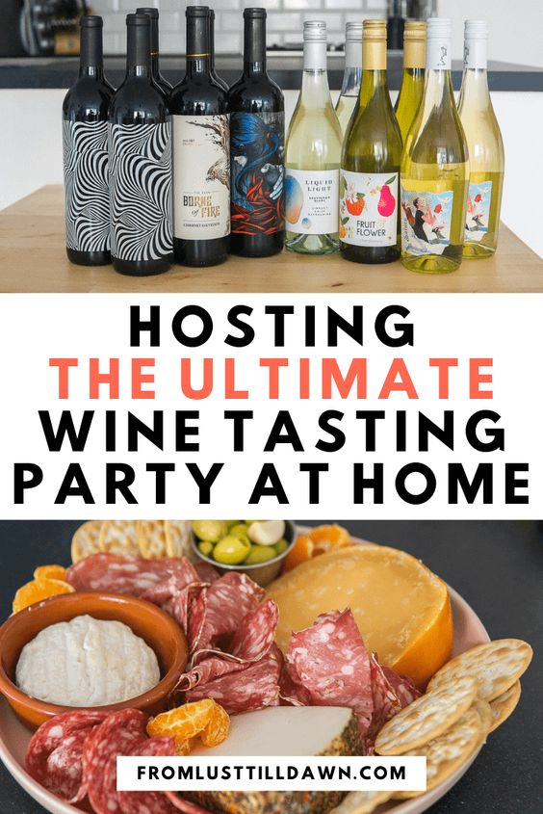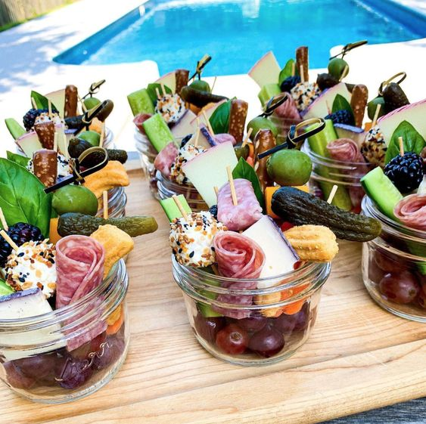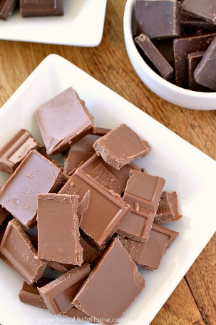

-Plan out when you want to host your wine tasting night.
-Choose a wine theme. (Region, Variety, Brand, Cost, Color). You should get two bottles of the same wine for parties of 8-10 people. Each bottle usually has about 10 servings. Suggested to have at least 3-4 varieties of wine in total.
-Plan out appetizers (cheese board, veggie tray, fruit plate, crackers, chocolate)
-Estimate how much glassware and food supplies you’ll need based on the number of invitees. (Two glasses per person, plates, water glasses, pitcher to dump out tastings, napkins)
-Order food wine and supplies!
-Send out invites. Suggested amounts of 8-10 people.
-Set up a table where everyone will do the tasting. Put out glasses, water, and the pitcher. Set up appetizers and snacks. (Make sure to chill white wines prior to the event!)
-Gather everyone around the wine table and have everyone try the first wine. Let discussion begin around flavor, color smell, etc. Repeat for other available wines. Enjoy the wine with friends!

